AAMBY VALLEY PHYSICAL AUCTION-BUYERS GUIDE
Step 1: Online registration on website: www.mstcecommerce.com/officialliquidatorbombay/aambyvalley/index.jsp
Note: Uploading of KYC and supporting documents can be done between April 17 & May 05, 2018 only.
Screen Shot of Registration Page in shown below: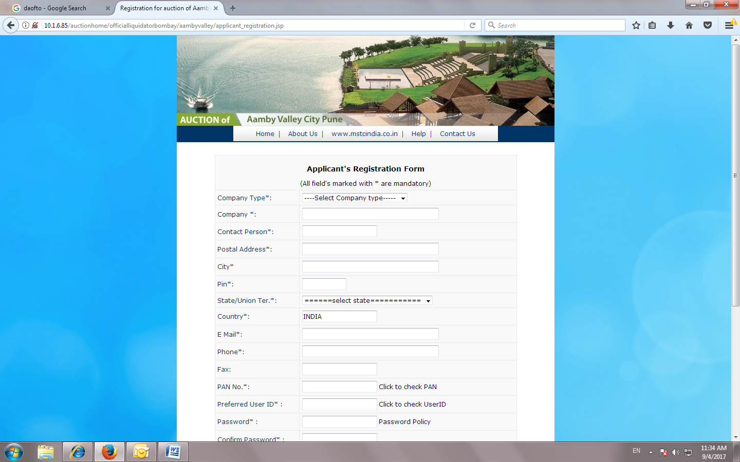
Step 2: You will receive an auto mail from MSTC detailing bank a/c details for payment of Registration Fee for activation of your login.
Step 3: Kindly make e-payment as per the email advise and forward your e-payment details to the email provided. Plz also include your user id details in your email so that we are able to activate your unique user id for access into the system. Class II signing DSC is reqd for access into the system.
Step 4: Once your login id has been activated, you will be able to view the KYC Form and upload signed and completed KYC Form along with the documents reqd. Plz note this has to be done within May 05, 2018.
Step 5: After scrutiny of the KYC Form and documents, those buyers who have been approved by Official Liquidator, Mumbai will be able to view the rest of the documents as outlined in the Tender Document.
Note: This can be done between May 05, 2018 and May 14, 2017, 2018 only.

